2/2/24, 2:02 PM Online Form | Mittagong Public School
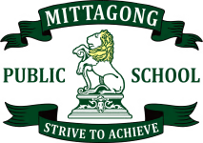

 Online Form -

MPS Swimming Carnival
Monday 12 February 2024 8:30am - 2:30pm
MPS Annual Swimming Carnival All students 3-6
Year 2 students who are 8 or turning 8 this year AND can competitively swim
50m without stopping.
$8.00
Bowral Swimming Centre (152 Mittagong Rd, Bowral NSW 2576)
Bessemer St Gate
Bowral Pool
Bus.
Students may wear their House Colours / school uniform.
All students will need the following items that are labelled with their name: Hat
Towel
Sunscreen Drink bottle
Recess and lunch.
Coloured zinc may be worn but cannot be shared with others.
Friday 9 February 2024

